
CEBU INSTITUTE OF TECHNOLOGY UNIVERSITY

N. Bacalso Avenue, Cebu City

DIGITAL SEISMOMETER with EARTHQUAKE ANALYZER

REQUIREMENTS SPECIFICATIONS

February 21, 2019

Cortezano, Clark Jay R.
Chewchut, Marvin Joshua P.
Damandaman, Keith Joseph B.

Chapter 1 Introduction

  - Purpose

Philippine Institute of Volcanology and Seismology, or commonly known as PHIVOLCS, requested CIT a cheap 24-bit digitizer on, if possible, all of their sensors like accelerometer, gas sensor, and etc. This project aims to create a digital seismometer which could be used as a reference circuit for their future digitizer circuits.

  - Scope

- This project aims to develop digitizer circuit which controls the conversion of analog signals from the sensors to digital signals and send it to database.
- This project contain API and earthquake analyzer software.
- The system has the capability to convert three analog signals from the accelerometer into three 24-bit digital data and send it to the Android phone.
- The Android software will store the converted data into a single file. The single file will contain location, output data speed, compass, and time information.
- The Android software will compress the file every minute and send it to the database. If the connection to the database is lost, the Android software will store the file to the external/internal storage temporarily.
  - Project Constraints and Limitations

- Data can only be accessed in the database and internal storage of Android Phone. Data in the internal storage can only be accessed during connection lost to the database.
- The digitizer should always be connected to the Android phone through Bluetooth.
- The calculated value of magnitude will only have a rough estimation.
- The database is open source for all but no security.
  - Hardware Requirements

- Microcontroller with minimum speed of 72 MHz and with 3 UART and USB
- 16 – bit resolution ADC Module
- Three Microcontroller with SPI and UART
- Android Phone
- Power Supply
  - Software Requirements

- MySQL
- Android Studio
- API
- C#
- TrueSTUDIO For STM32
- STM32CUBEMX
- ST-LINK
  - Definitions of Terms

- ADC (Analog to Digital Converter) is a component used for this project to convert analog signals from the sensor to its digital form.
- UART (Universal Asynchronous Receiver-Transmitter) is an interface that uses asynchronous serial communication between peripherals.
- SPI (Serial Peripheral Interface) is an interface that uses synchronous serial communication between peripherals.
- RTC (Real Time Clock) is a module used for getting time or date information.
- GPS (Global Positioning System) is a satellite-based radionavigation system owned by the US government and operated by the United States Air Force.
- USB CDC (Universal Serial Bus Communication Device Class) - is a composite Universal Serial Bus device class. USB CDC is one of the common communication protocol used for communicating Android devices with other devices.

  - References

- https://searchmobilecomputing.techtarget.com/definition/GPRS
- https://en.wikipedia.org/wiki/Universal_asynchronous_receiver-transmitter
- https://en.wikipedia.org/wiki/Global_Positioning_System
- https://en.wikipedia.org/wiki/USB_communications_device_class
- https://earthquake.usgs.gov/learn/topics/mercalli.php
- https://www.sciencedirect.com/science/article/pii/S1738573317304564
- https://www.youtube.com/watch?v=HseRUq-IACw
- https://sciencing.com/differences-between-waves-8410417.html
- https://www.livescience.com/40102-accelerometers.html
- https://en.wikipedia.org/wiki/Accelerometer
- https://www.ncbi.nlm.nih.gov/pmc/articles/PMC4268708/
- https://is.muni.cz/th/ihit0/?lang=en

Chapter 2 System Analysis

  - System Architecture
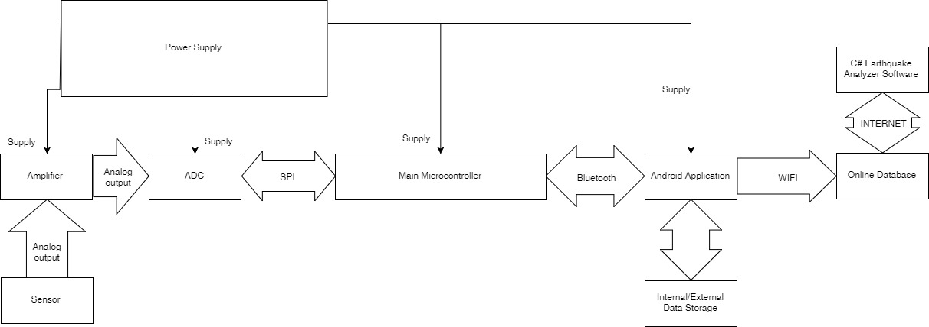
Figure 2.1 System Architecture

The major components of this system are the following: Microcontroller, ADC, and Android Phone. All the connections or interfaces are defined in the above diagram. The GPS and RTC module is already incorporated to the Android Phone. Generated data from the system will be sent to an online database via WIFI. The online database will be host by PHIVOLCS. A power supply will power-up the major components. The connection of internal/external data storage is already implement by the Android phone.

  - Flowcharts
    - General Flowchart
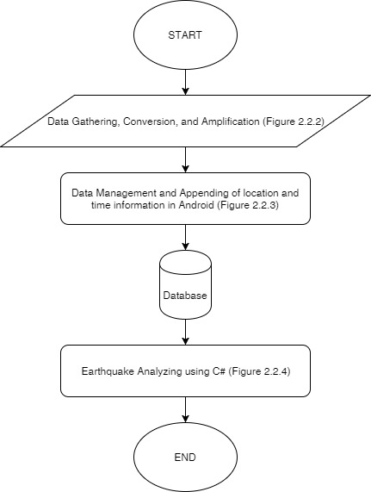
Figure 2.2.1 General Flowchart
Figure 2.2.1 shows the general flowchart of the system. This describes the overall flow of the system from data gathering until C# back end software of the system.

    - Data Gathering, Conversion, and Amplification
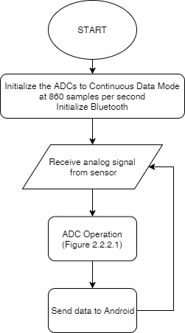
Figure 2.2.2 Data Gathering, Conversion, and Amplification
This figure shows the general flowchart of data gathering, conversion, and amplification. Sub flowcharts, figure 2.2.2.1 and 2.2.2.2, will be shown below.

      - ADC Operation
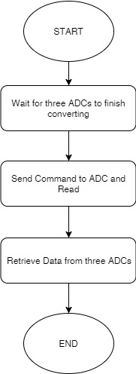
Figure 2.2.2.1 ADC Operation
The ADC module is controlled by a sub microcontroller which is responsible for data acquisition request. The figure above shows the flowchart of data acquisition of the sub microcontroller.

    - Data Management and Appending of location and time information in Android

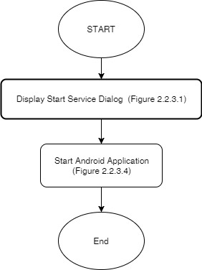
Figure 2.2.3 Android Software General Operation
The figure above shows the general operation of the android software. The Android software is responsible for appending time and location information to the received raw data, creating back-up, sending data to an online database, and displaying the data in a graphical form using Android phone. The process above shows that it will prompt a dialog box that will ask information from user for starting the services. After these necessary actions, It will start the services together with user interface.

      - Display Start Service Dialog
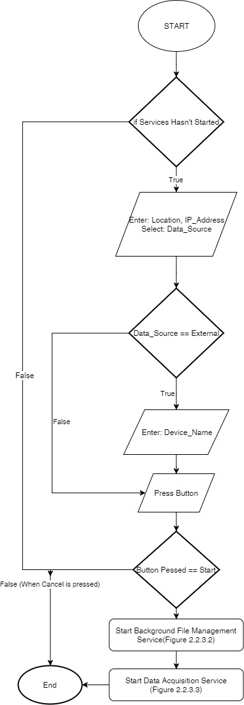
Figure 2.2.3.1 Display Start Service Dialog
The figure above shows the flowchart of dialog box during start-up. This dialog box will ask information from user for starting the necessary services.
      - Background File Management Service

      - Data Acquisition Service
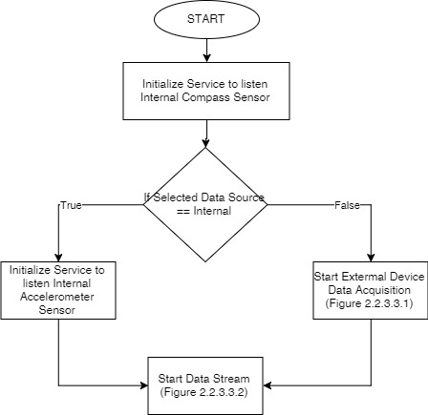
Figure 2.2.3.3 Data Acquisition Service
The figure above shows the general flowchart of data acquisition service. The service purpose is to listen data from internal or external sensor and broadcast the data in order for activity and services to receive the data. It will send notification when connection is lost or gain and the source of data.

        - External Device Data Acquisition
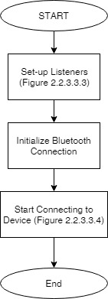
Figure 2.2.3.3.1 External Device Data Acquisition
The figure above shows the general flowchart of external device data acquisition service. The service purpose is to listen data from external sensor and broadcast the data in order for activity and services to receive the data. It also reconnects to the said external device during loss of connection. It will send notification when connection is lost or gain.

        - Data Stream
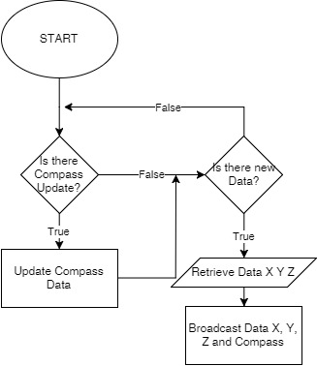
Figure 2.2.3.3.2 Data Stream
The figure above shows the flowchart of data streaming. The purpose of this functionality is to broadcast data from internal or external sensor. The data contains compass, x, y, and z values.

        - Setup Listeners

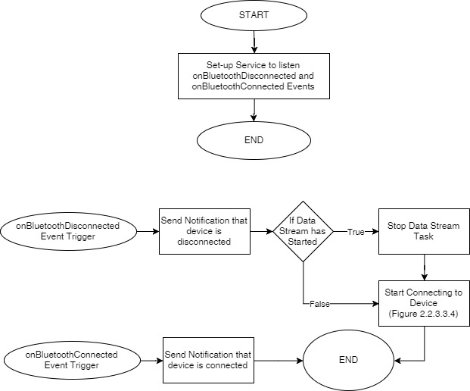
Figure 2.2.3.3.3 Setup Listeners
The figure above shows the flowchart during listener set-up. The functionality only triggers when user selected the external data source mode. The purpose of this function is to listen events on changes of Bluetooth connection state and do appropriate actions.

        - Connecting to Device
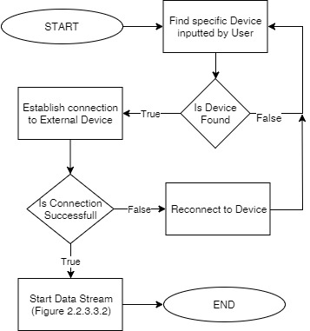
Figure 2.2.3.3.4 Connecting to Device
The figure above shows the flowchart during connecting to external device. This functionality only triggers when user selected the external data source mode. It uses the information from the device name inputted by the user.

      - Android Application
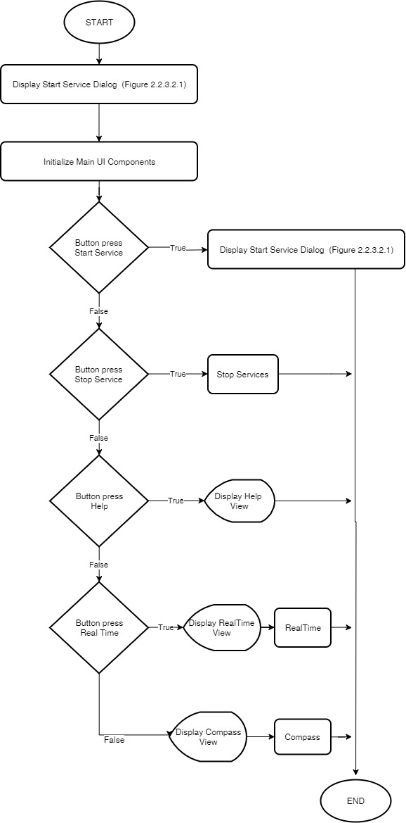
Figure 2.2.3.4 Android Application
The figure above shows the flowchart after the user inputted the necessary information for starting the service. This flowchart describes the main user interface of the android application.
      - Data Back-Up and Send file to the Server
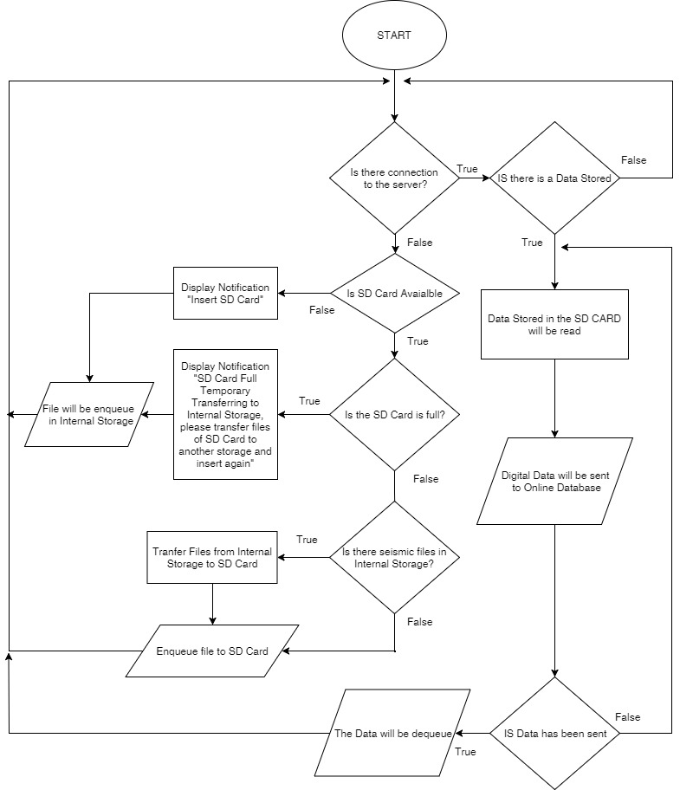
Figure 2.2.4.3 Data Back-up and Send File to Server
The figure above shows the sub function of the Background File Management Service of the Android software. Its main function is to generate back-up and send file to the database.
    - Earthquake Analyzing using C#
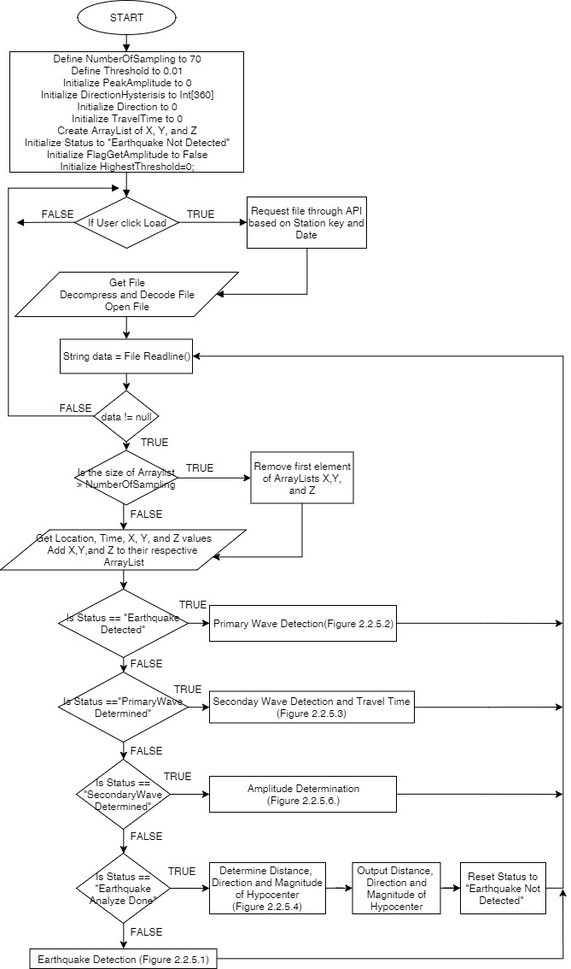
Figure 2.2.5 Earthquake Analyzing using C#
The figure above shows the general flowchart of the back end C# application. The status variable will define the status of the embedded Earthquake Detector.
      - Earthquake Detection
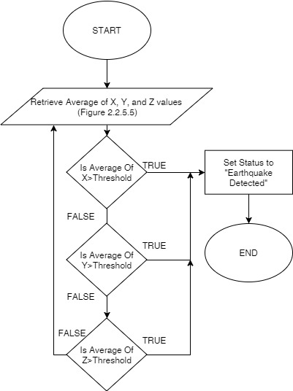
Figure 2.2.5.1 Earthquake Detection
The figure above defines how the software determines if it is an earthquake or not. It uses averaging of samples of X, Y, and Z to get the average value of the data. Please see Figure 2.2.5.5 to get details about average values of the data.

      - Primary Wave Detection
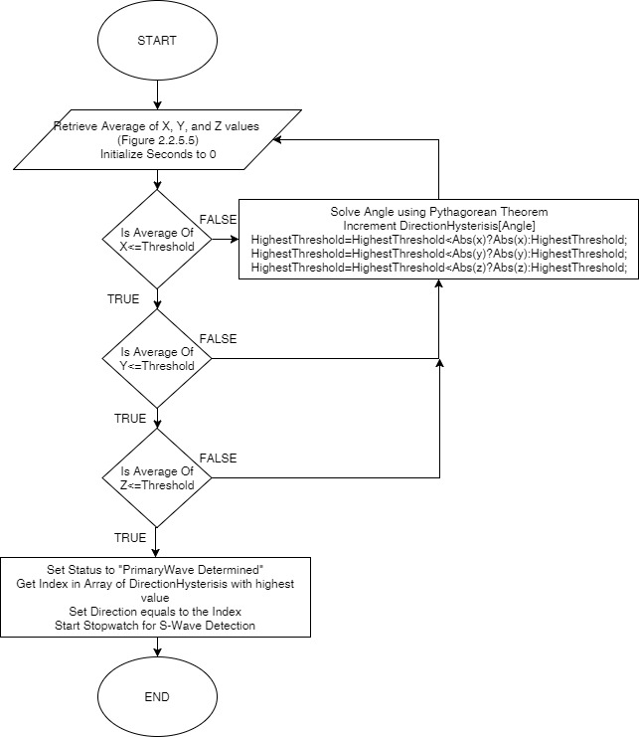
Figure 2.2.5.2 Primary Wave Detection
The figure above defines how the system determine if a primary wave has ended or not. This function will only trigger if the software has detected an earthquake.
      - Secondary Wave Detection and Travel Time Determination
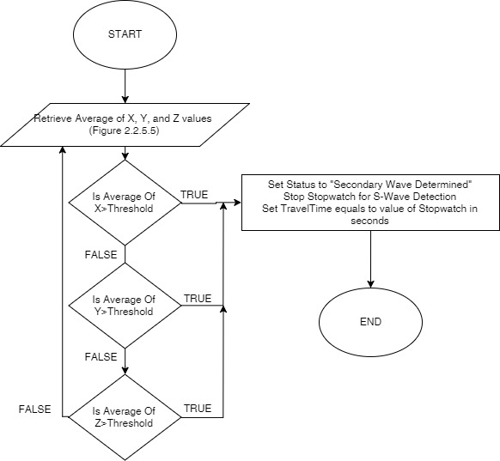
Figure 2.2.5.3 Secondary Wave Detection and Travel Time Determination
The figure above defines how the software determine if a secondary wave has occur. Secondary wave must be higher than primary wave. The function will only trigger if the software has determined a primary wave. Travel time defines the time travel starting from the arrival of primary wave until the arrival of secondary wave.

      - Determine Distance, Direction, and Magnitude of Hypocenter
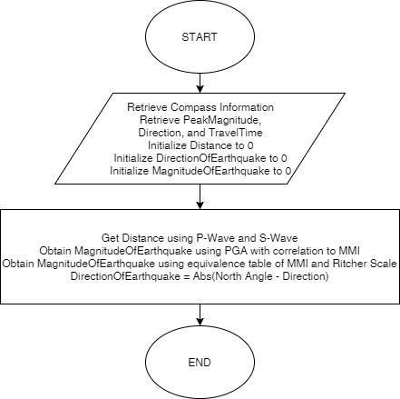
Figure 2.2.5.4 Determine Distance, Direction, and Magnitude of Hypocenter
The figure above defines how the software solve for distance, direction, and magnitude of hypocenter. In this case, distance traveled by the wave is define as the Travel Time multiply by 8 which is a standard speed of travelling waves. Magnitude and Direction of the hypocenter is defined above.

      - Retrieve Average Values of X, Y, and Z
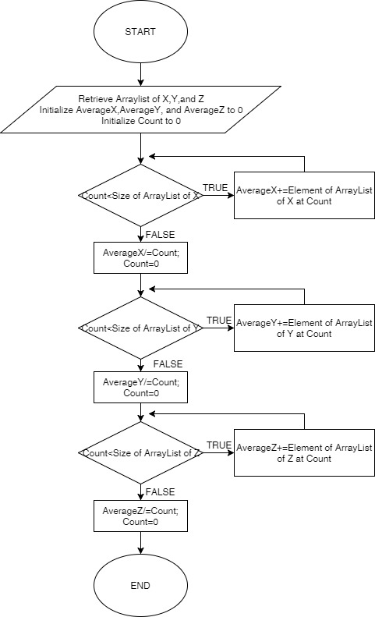
Figure 2.2.5.5 Retrieve Average Value of X, Y, and Z
The figure above works like a circular queue. It uses averaging of samples by gathering the samples and put it into the circular queue.
      - Peak Amplitude Determination
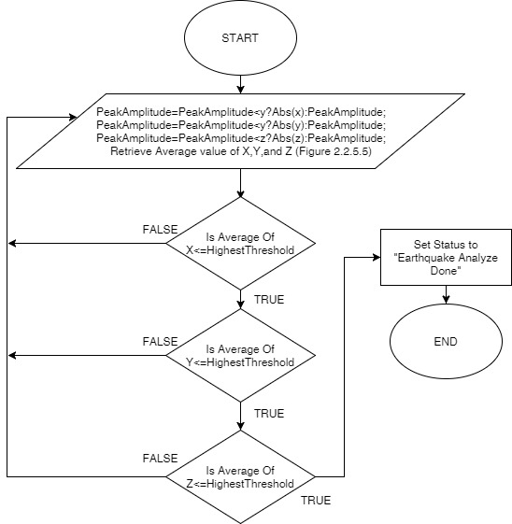
Figure 2.2.5.6 Peak Amplitude Determination
The figure above defines how the system determine the peak amplitude of the earthquake. The software will pick the highest absolute value of g from the three axis.

  - Data Flow Diagram
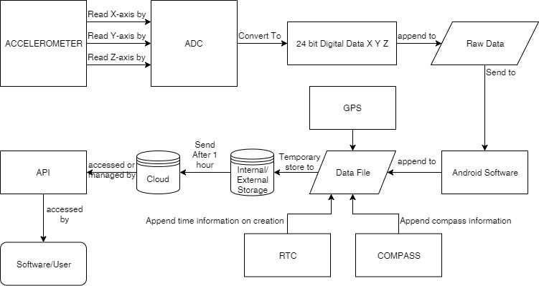
Figure 2.3 Data Flow Diagram

Figure 2.3 shows the data flow diagram of the system. The raw data contains time and three 24-bit Digital Data of x, y, and z. The android software acts as an intermediary software which will append digital data, location, time, and compass information to the file before sending it to Server.

  - Entity-Relationship Diagram
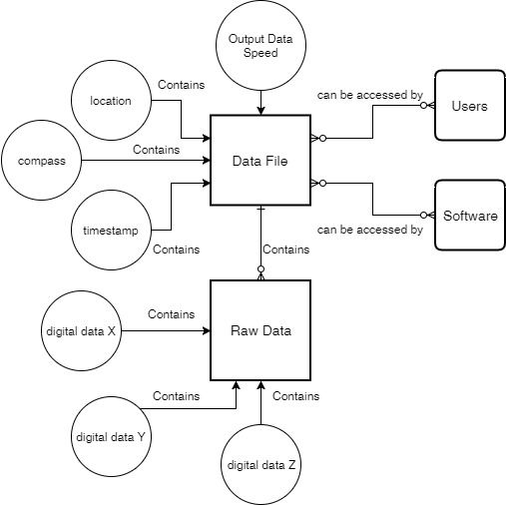
Figure 2.4 Entity-Relationship Diagram

Chapter 3 Functional Requirements

  - ADC
The device has an ADC module which is responsible for converting analog input to digital output. The result of digital data conversion corresponds to the analog voltage input with respect to reference voltage. The ADC module accepts data from the accelerometer and convert the signal into digital form which will be used as reference data for analyzing earthquake.

    - 3 Channel analog conversion
Since most of the accelerometer has a 3 analog output corresponding to 3 axis(x, y, and z axis), the device has a capability of accepting 3 analog voltage inputs and converting it to digital form.

    - 24-bit Digital data resolution
The device needs to be sensitive enough to detect minute changes of analog voltage. Due to the nature of the device, ADC module should have a capability to convert at least 24-bit of Digital Data.

  - Earthquake Analyzer
Earthquake Analyzer is a C# software application that uses API to communicate with database containing all sets of data from the device. The software will convert all the data into a readable or understandable form of GUI. The software can be accessed by users and can be made as a reference software for future application related to this project.

    - Direction of Hypocenter
Using the method of getting the resultant vector, the direction of the epicenter can be solve by first getting the resultant vector of x and y axis only. The vector shall be compared with the resultant vector of x and y axis with the North by getting the difference of angle of the two vectors. The angle of resultant vector of the compass shall be the minuend and other as the subtrahend. The difference of the angles shall be the number of degrees from the North direction.

    - Magnitude of Hypocenter
The magnitude of the hypocenter can be calculated by using Modified Mercalli Scale. The peak amplitude in g of the seismic wave will be used to get the peak ground acceleration. This peak ground acceleration will be used to get the value in terms of Mercalli Scale. The value in terms of Mercalli scale will be converted into Richter scale. The value in Richter scale will be the output magnitude value of the hypocenter.

    - Distance of Hypocenter
The distance of the hypocenter can be calculated using P-Wave and S-Wave. The software will record the time between the arrival of P-Wave and S-Wave. This will be used to get the distance of the hypocenter. In our case, the speed of the wave to be used is 8 km/sec which is the standard speed PHIVOLCS used.

  - Android Software
The android device act as an intermediary device where its main role is to display and send data to the online database. The android device receive data from the digitizer through USB to ensure that there will be no problem on its connectivity.

    - Real Time Mode
When the user selects the real time mode, the software will display its updated data in a graph manner.

    - Compass Mode
In compass mode, the software will display a compass that will give user information of where is the direction of the North with respect to the phone’s perspective.

    - Background file management
The android software has background process to automatically compress, generate back-up, and send the files to the server. Compressing and sending the file to the server occurs every two mins of data acquisition. The filename, as stated from the flowchart, is based on the time of creation. The format of the file is based on the format used by PHIVOLCS. The software will automatically back-up its data either to internal or external storage of the phone when connection to the database is not present. Every time there is connection, the data will be then move to the database.

    - Timestamp
Every time the microcontroller will receive complete data from ADC containing x, y, and z digital values, the device will automatically append time information on the data. The time information will serve as a mark of when does the data gathered which is useful for generating series of movement of the earth at a particular time.

    - Location of Device
The system, upon installation of the device, will save its coordinates using the GPS functionality of the android device. That location will be part of the raw data that will be sent in the database.

Chapter 4 User Interface

  - Main User Interface
The real time reading of the seismometer, the x, y and z axis, is displayed at the center of the screen with the analysis of the peak magnitude and the direction. A drop down menu is displayed in the upper left corner of the screen. When the drop down menu is pressed, it will display the other controls like load data, real time, and orientation buttons.
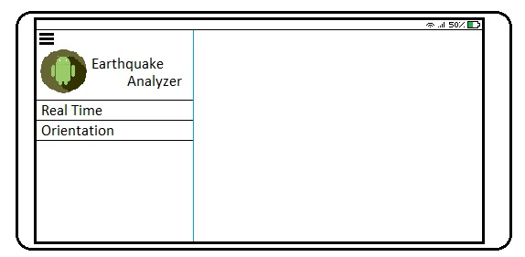
Figure 4.2 Menu UI
  - Menu
The menu control displays a drop down list of other controls. The Sub controls are: Load Data, Real Time, and Orientation controls. The menu GUI, as shown in figure 4.2, shows the different controls.

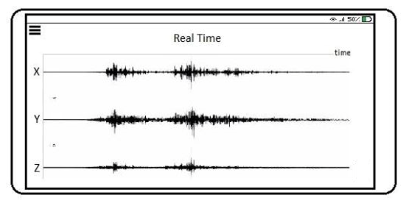
Figure 4.2.1 Real Time Mode UI

    - Real Time Mode
Real Time is a control which will return to the Real Time reading screen. Figure 4.2.2 shows the Real Time GUI.

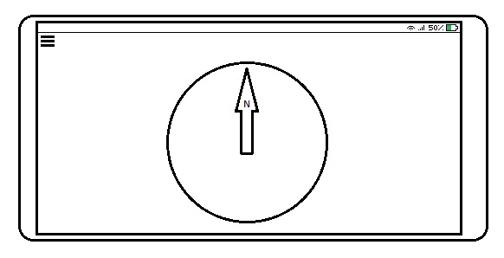
Figure 4.2.2 Compass Mode UI

    - Compass Mode
Orientation is a control which will display the orientation screen. Figure 4.2.3 show the Orientation GUI.

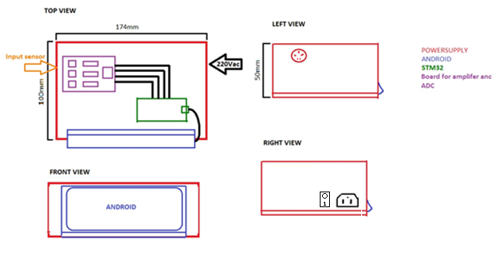
Figure 4.2.3 Hardware User Interface

    - Hardware User Interface
The hardware user interface contains switch button for power, power port, and input port for sensor. The input port, which is found on the left side view, consists of x, y, and z input ports. The switch and power port can be found on the right side view of the hardware. In the front view, the Android phone can be found. For our set-up, the sensor should be aligned to y-axis of the Android phone.

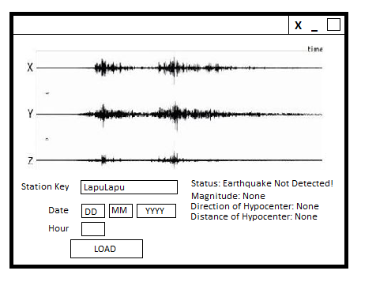
Figure 4.2.4 Earthquake Analyzer Interface
    - Earthquake Analyzer Interface
Figure 4.2.4 shows the user interface for the Earthquake Analyzer software. The user will be asked to input a station key, date, and hour of the file that the user wanted. When the user click “Load”, the software will request the file though API.

Version | Date of Release | Change/Updates | Contributors | Documented by
1.0 | Sept. 10, 2018 | Creation of Document | Marvin Joshua Chewchut  Clark Jay Cortezano  Keith Joseph Damandaman | Marvin Joshua Chewchut
2.0 | Sept. 22,  2018 | Revision of Document | Marvin Joshua Chewchut  Clark Jay Cortezano  Keith Joseph Damandaman | Marvin Joshua Chewchut
3.0 | Oct. 1, 2018 | Revision of Document | Marvin Joshua Chewchut  Clark Jay Cortezano  Keith Joseph Damandaman | Marvin Joshua Chewchut
4.0 | Oct. 2, 2018 | Revision of Document | Marvin Joshua Chewchut  Clark Jay Cortezano  Keith Joseph Damandaman | Marvin Joshua Chewchut
5.0 | Oct. 25,2018 | Revision of Document | Marvin Joshua Chewchut  Clark Jay Cortezano  Keith Joseph Damandaman | Marvin Joshua Chewchut  Clark Jay R. Cortezano
6.0 | Oct 28,2018 | Revision of Document | Marvin Joshua Chewchut  Clark Jay Cortezano  Keith Joseph Damandaman | Marvin Joshua Chewchut
7.0 | Dec 05,2018 | Revision of Document | Marvin Joshua Chewchut  Clark Jay Cortezano  Keith Joseph Damandaman | Marvin Joshua Chewchut

